L-8

Continuation of Operators and Loops in Java

Question-1 What are the conditional operators in java?

Ans-

In java, the conditional operator is the ternary operator, also known as the “conditional operator”.

The syntax of the conditional operator is as follows:

CONDITION ? Value_if_true : value_if_false

The ‘condition’ is a Boolean expression that is evaluated to determine whether the result

true or false. If the ‘condition’ is true, then the value of ‘value_if_true’ is returned,

Otherwise the value or ‘value_if_ false’ is returned.

Here's an example that uses the conditional operator to assign a value to a variable:

Int x = (a > v) ? a : b;

The given example , the value of ‘x’ is assigned the value of ‘a’ is greater than ‘b’, otherwise the value of ‘b’ is assigned to ‘x’.

Question 2- What are the types of operators based on the number of operands?

Ans-

Operators can be classified based on the number of operands they take. Here are the different types of operators based on the number of operands:

1. Unary operators: unary operators are operators that work on a single operand. They perform an operation on the operand and return the result. Examples of unary operators are the negative sign (-), the logical NOT (!), and the increment (++) and decrement (--)operators.
2. Binary operators: Binary operators are operators that work on two operands. They perform an operation on the two operands and return the result. Examples of binary operators are the arithmetic operator (+,-,*,/,%), the comparison operators (==, !=,<,>,<=,>=),the logical operators(&&,||), and the assignment operator(=).
3. Ternary operator: The ternary operator is the only operator in /java that takes three operands. It is also known as the conditional operator . It works by evaluating a boolean expression and returning one of two values based on the result of the evaluation. The syntax of the ternary operator is :

‘Boolean_expression ? value_if_true : value_if_false’.

Question 3- What is the use of switch cases in Java programming ?

Ans-

The switch case statement in java is a control flow statement that is used to test the value os a variable or expression and then perform different actions based on the value. The switch case statement is typically used as an alternative to if-else if ladder when you have multiple conditions to test against a single value.

The general syntax case statement in java as follows:

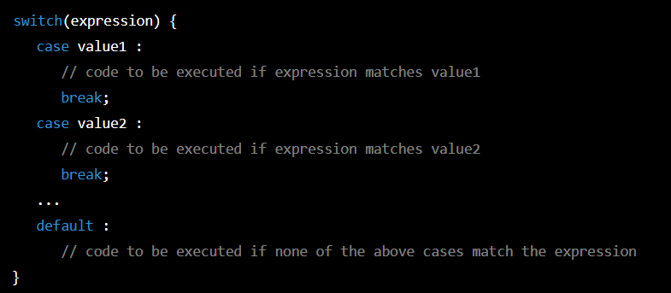

Here, the expression is evaluated and compared with the values of each case statement. If a match is found, the code within that case statement is executed. The ‘break’ keyword is used to terminate the switch block and exit the statement.

The switch case statement can be useful in scenarios where you have a large number of conditions to test against a single variable or expression. It can make our code more readable and easier to maintain than a long if-else ladder.

Question 4- What are the priority levels of arithmetic operation in Java ?

Ans

In java, arithmetic operations are performed according to the following priority order(high to lowest):

1. Unary operators: ++, -- (increment and decrement operators)
2. Multiplication, division, and remainder operators: *,/,%
3. Addition and subtraction operators: +, -
4. Shift operators: <<, >>, >>>
5. Relational operators: <, <=, >, >=
6. Equality operators: ==, !=
7. Bitwise AND operators: &
8. Bitwise XOR operators: ^
9. Bitwise OR operators: |
10. COnditional AND operators: &&
11. Conditional OR operators: ||
12. Ternary operators: ?:
13. Assignment operators: =, +=, -=, *=, /=, %=, <<=, >>=, >>>=, &=, ^=, |= .

Question 5- What are the conditional statements and use of conditional statements in Java?

Ans-

Conditional statements in Java are used to execute a certain block of code based on a specified condition. There are two main types of conditional statements in Java: if statement and the switch statement.

The if statement allows a program to make a decision based on the value of a boolean expression.

The syntax of the if statement is as follows:

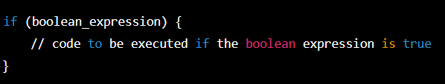

For example:

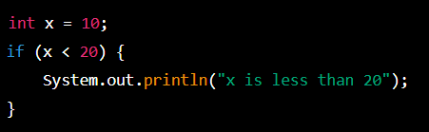

In this ex- the program will print “x is less than 20” because the boolean expression “ x< 20” is true.

The switch statement is used to select one of several blocks of code to be executed based on the value of a single expression. The syntax statement is as follows:

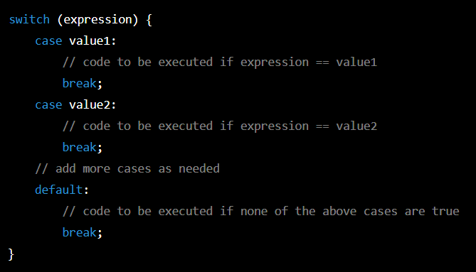

For example:

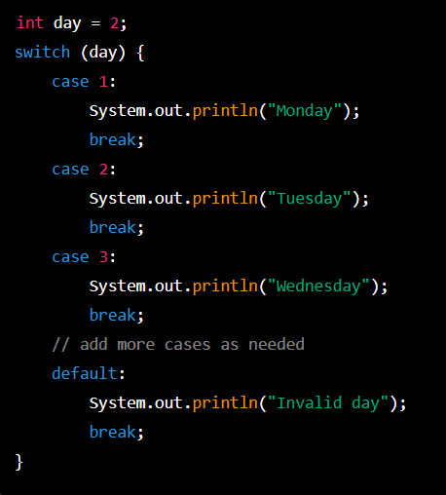

In this above example, the program will print “Tuesday” because the value of the expression “day” is 2.

Question 6- What is the syntax of if else statement?

Ans-

The syntax for an if-else statement in most programming languages as follows:

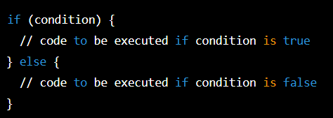

In this syntax, ‘condition’ is a logical expression that evaluates to either true or false. If the condition is true, the code inside the curly braces after the ‘if’ keyword will be executed, otherwise the code inside the curly braces after the ‘else’ keyword will be executed.

In some programming languages, the ‘else’ keyword can be omitted if we only want to execute code when the condition is true. In this case, the syntax would be:

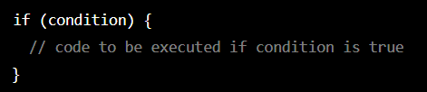

Question 7- What are the 3 types of iterative statements in java?

Ans-

In Java, there are three types of iterative statements:

1. The ‘for’ loop: The ‘for’ loop is used to execute a block of code repeatedly for a fixed number of times. If consists of an initialization statement,a condition, and an update statement, all separated by semicolons.
2. The ‘while’ loop: the ‘while’ loop is used to execute a block of code repeatedly as long as a condition is true. It consists of a condition and a block of code, and the loop will continue to execute the block of code as long as the condition is true.
3. The ‘do-while’ loop: it is similar to the ‘while’ loop, but it guarantees that the block of code will be executed at least once, even if the condition is initially false. It consists of a block and a condition, and the loop will continue to execute the block of code as long as the condition is true.

Question 8- Write the difference between for loop and do-while loop?

Ans-

THe main difference between a ‘for’ loop and a ‘do-while’ loop is that the ‘for’ loop executes zero or more times based on a condition, while the ‘do-while’ loop executes at least once before checking the condition.

IN a ‘for’ loop, you specify an initialization expression, a condition expression, and an increment expression. The loop will contain an expression, a condition expression evaluated to ‘true’. The initialization expression is executed br=efore the loop begins, and the increment expression is executed after each iteration of the loop. Here’s an example of a ‘for’ loop:

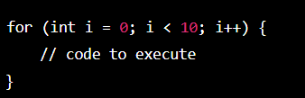

In a ‘do-while’ loop, you specify a block of code to execute and a condition expression. The block of code is executed once before checking the condition expression. If the condition expression evaluates to ‘true’, the loop will continue to execute. Here’s an example of a ‘do-while’ loop:

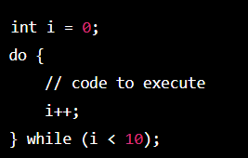

In simple words, the key difference between a ‘for’ loop and a ‘do-while’ loop is that the ‘for’ loop may execute zero times if the condition is false initially, while the ‘do-while’ loop always executes at least once before checking the condition.

Question 9- Write a program to print numbers from 1 to 10.

Ans

Java

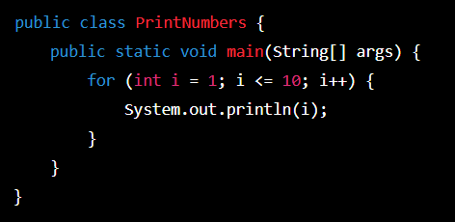

output:

